
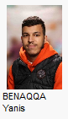
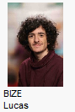
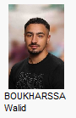

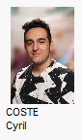

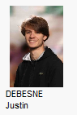
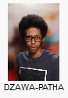Emile
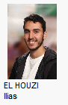

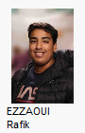
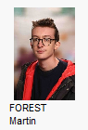

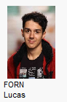
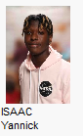
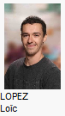

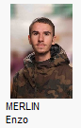
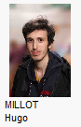
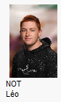
Ruben

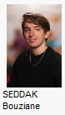
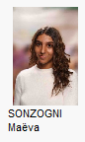
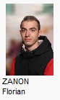
DJIAB Mohamed

